**Project Development Phase**

**No. Of Functional Features Included in The Solution**

|  |  |
| --- | --- |
| Date | 3 November 2023 |
| Team Id | NM2023TMID03725 |
| Project Name | Create a Google My Business profile |

**Functional Features Included in The Solution:**

1. Business Name: Frea Bath and Bodyworks
2. Business Category: Local "Artisanal Soap Maker".
3. Contact Information: 88888xxxxx
4. Business Hours: Monday to Saturday 10.00 am to 5.00 pm.
5. Photos:

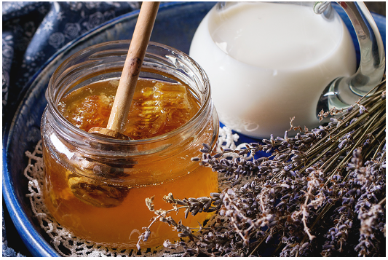 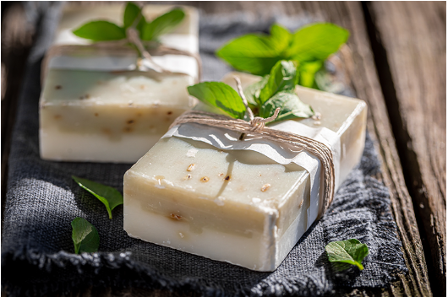

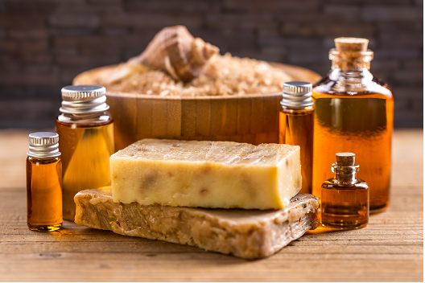

1. Description: Soap Bar - **Bar soaps** can be considered one of the most common and widely used cleansers and include essential cleansing ingredients that remove dust and toxins from the skin. Shower Jel - Curated as a liquid formula for cleansers, body washes and shower gels are often seen as the same thing because of their texture when both their foundations are very different.
2. Attributes: These 100% natural soap bars deeply cleanse the skin whilst nourishing and lending it a delicate fragrance that lingers. Unlike other luxury soaps, the ones at Forest Essentials are hand-made and free from any petroleum, synthetic fragrances, and harmful chemicals.
3. Messaging: Enable messaging to allow potential customers
4. Special Hours: During Sunday shop will be open from 10.00am to 12.00 noon.